APPLIED PROJECT
RESEARCHERS CONNECT
PROJECT CODE:CPL-5559-CSAT-0026



LAMBTON COLLEGE IN TORONTO

GROUP MEMBERS:
JASPREET KAUR BHATTI(C0696636)
JATINDER SINGH SANDHU(C0708843)
HARSIMRAN SINGH(C0707995)
SWARNJIT KAUR DHANDA(C0708048)
SAROJ KUMARI(C0706539)

WEEK1:

Task:

Purpose:Our project is on Researchers Connect which is build in visual studio software based on c# language and database connectivity using Microsoft SQL Server Management Studio.The motive of this project is to design web based application.

Intended Audience:As the scope of this application is to provide Users/Researchers to view their profiles as well as other Researchers who are register on Researchers Connect web application.

Product Scope:. The scope of this application is to provide a Researchers web-based application that allows them to register,create a profile and search about a particular file of other Researchers.It is similar to LinkedIn or Facebook but only for Researchers.

Overall Description:

Register:This is the first page of our project which contains first name,last name and many other fields where user can register his information according to available fields and if user fails then it will provide validation errors.
Login:It is the page where the user who has already an account can do the login otherwise the user need to do a SignUp with a new account and when user will be successful then it will go to the profile page.
Profile:It is the welcome page of our application where if user has successful login then it will provide a complete information of a user.

WEEK2:

Task:
Ou role was same as ‘System Analyst’.We created a SRS document and passed it to client.Researchers Connect team has provide us a few hand-designed screenshots and they expected us to convert them to computer-designed user-interface mock-ups.

Tools used to generate user-interface mock-ups:

- Microsoft Visio

- InVision

- Zeplin

- Axshare

- Balsamiq

- MockFlow

Here is the screenshot of all the tools generate user-interface mock-ups :

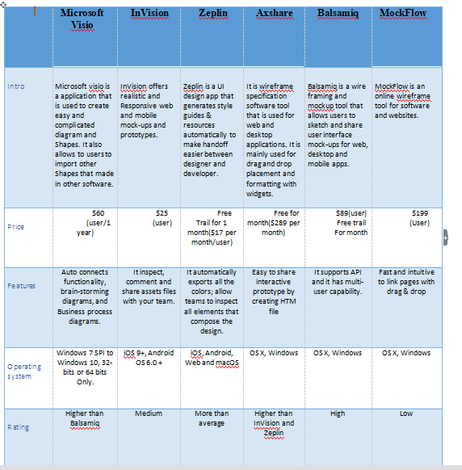

PNG FILES:

Main Login page:It is the first page of our application in which it contains two fields username and password.If the user has already an account the he can do login through LOGIN button otherwise the user need to register first by filling all the registration form.

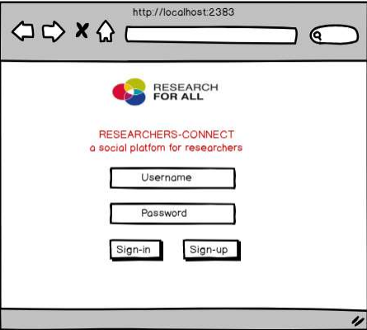

Registration Page:This is the register page where we have first name,last name,email,password,age,gender and language fields and at the bottom their s a Register button.By using this page user can create his account on our application and when user will be successful then he can only login and access the profile page.

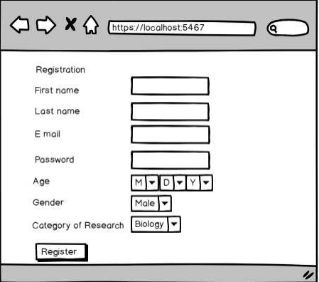

Profile Page:

This is the welcome page of our application where the user who has an account can only access this page.It contains a profile picture at left side and Search button on the right side.At the bottom their is a Logout Button.This page displays all the user information .

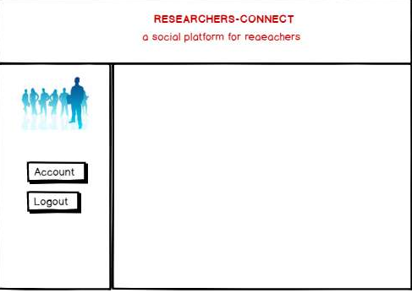

WEEK3:

Task:
This document describes the function of web application where all the members worked as a ‘Software Developer’ and deal with database connectivity using SQL Server.Our motive was to use the SQL commands in the coding to fetch the data related to the user from the database.We created a database with all fields for ResearchersConnect web application.

Here is the Output of Login Page:

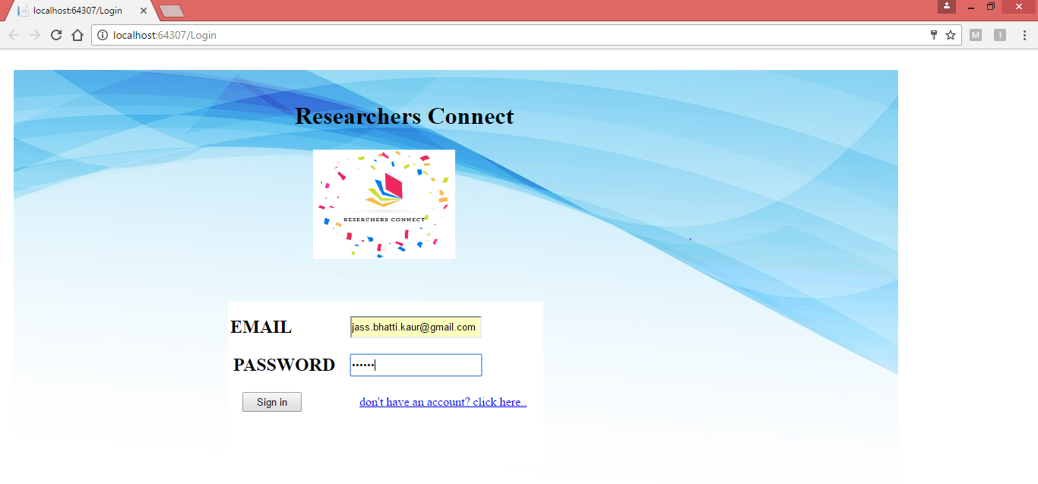

Here is the Screenshot of fields of a table register:

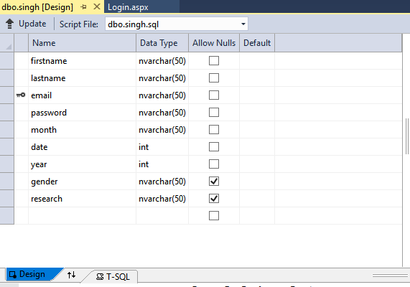

Here is the Screenshot of all the values of a register table :

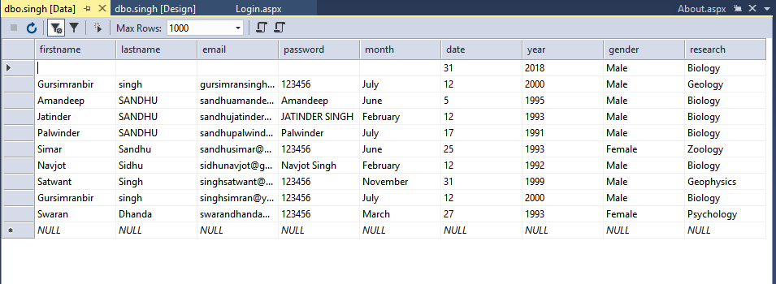

WEEK4:

Task:
The purpose of this document is to describe the function of web application that navigate from one page to another page like if user clicks on Sign Up page then it will directly takes to Registration page.Moreover,if the if the user creates an account through registration form then all the data will be stored in the database.For the database,we had created two tables one for each page and used SQL commands to save and retrieve the data.

Here is the screenshot of Register page:

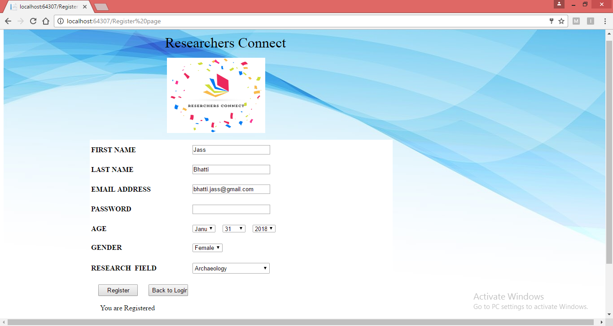

Here is Screenshot of all the values of a register table :

WEEK5:

Task:
During this week,all the members worked on database tool selection,database tables/fields and ERD diagram.Based on the database management, we created tables and appropriate fields.We made a SQL connection and how all the tables and database makes a connection using a String in the coding.

Database Tools Connection:
We are using MYSQL database to store all the data of our project.It is one of the free and open-source software that manages effective management of database.It has high performance of distinct storage framework.

Database Tables/Fields:The below image shows all the fields of registration page in a Microsoft SQL Management.

Here is the screenshot of all the values in a database:

The below image shows all the values of registration page in a Microsoft SQL Management:

DATABASE ERD:

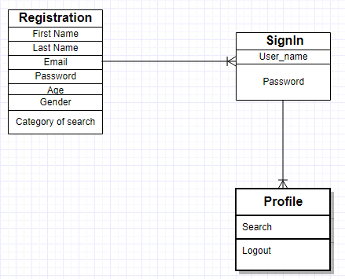

WEEK 6:

Task:

Product Perspective:
The first web form of our project which contains first name,last name and many other fields where user can register his information according to available fields and if user fails then it will provide validation errors.
It is the page where the user who has already an account can do the login otherwise will give an error and when user will be successful then it will go to the profile page.All the information which is updated on local host is stored in the SQL database which is connected to the source code through string connection.

Here is register page when user clicks a Register button entering all fields:
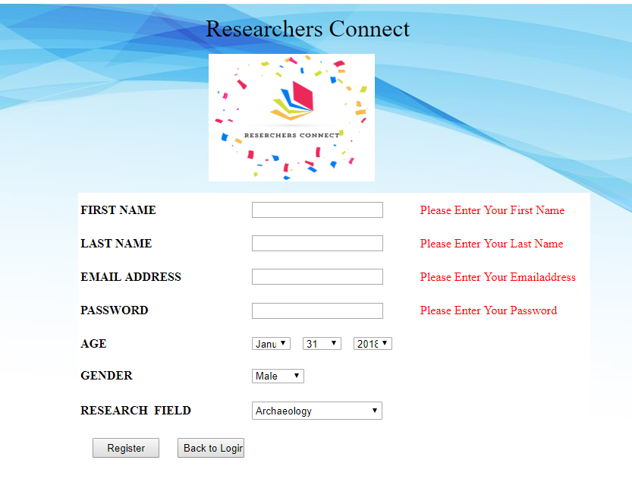

WEEK7:

Task:

All the information of all the pages is stored in the database is in the form of tables including their particular fields.As in the source code we have used the Exception handling concept which assists to manage the errors of a source code and when it shows an error then it will throw an exception.

Here is the page when user is successful to register:

WEEK 8:

Task:

At this stage,our almost work was done so our task is now to test the code where group members worked as ‘Software Tester’.By using this,we found many test cases and we went through all of them and found the solutions for them.Here are some test results using Microsoft Excel Sheet with the given items.

Here are some Test Cases :

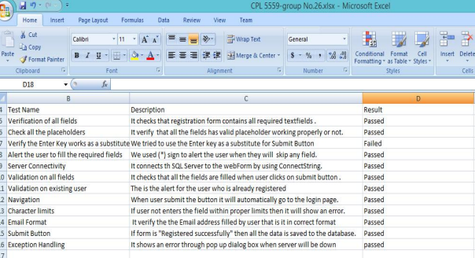

WEEK9:

Task:
Being a software developer ,team had done the functionality on web application.We have done the functionality on login page means when user will enter invalid entries then it will inform us through a message and the entries are valid then the profile page will open.For the Registration page,if user enter all the entries by following pattern then all the data will be saved in database.

Following is the functionality of Register Page:

Description of source code of registration page:

using System.Web.UI;
using System.Web.UI.WebControls;
using System.Data.SqlClient;
using System.Data;
using System.Configuration;

namespace Final_Project
{
public partial class Register_page : System.Web.UI.Page
{
public string cnstring=("Data Source=(localdb)\\MSSQLLocalDB;Initial Catalog=Database1;Integrated Security=True");
protected void Page_Load(object sender, EventArgs e)
{

}

protected void Button1_Click(object sender, EventArgs e)
{

try
{

SqlConnection con = new SqlConnection(cnstring);
con.Open();

string command = "INSERT INTO singh(firstname,lastname,email,password,month,date,year,gender,research)VALUES(@firstname,@lastname,@email,@password,@month,@date,@year,@gender,@research)";
SqlCommand cmd = new SqlCommand(command, con);
cmd.Parameters.AddWithValue("@firstname", TextBox1.Text);
cmd.Parameters.AddWithValue("@lastname", TextBox2.Text);
cmd.Parameters.AddWithValue("@email", TextBox3.Text);
cmd.Parameters.AddWithValue("@password", TextBox4.Text);
cmd.Parameters.AddWithValue("@month", DropDownList1.Text);
cmd.Parameters.AddWithValue("@date", DropDownList2.Text);
cmd.Parameters.AddWithValue("@year", DropDownList3.Text);
cmd.Parameters.AddWithValue("@gender", DropDownList4.Text);
cmd.Parameters.AddWithValue("@research", DropDownList6.Text);
cmd.ExecuteNonQuery();
Label1.Visible = true;
// Response.Redirect = "Login.aspx";
}
catch(Exception)
{

Label1.Text = "something went wrong";
throw;
}
finally
{

}

}}}

WEEK10:

Task:
The given task was about to finish the requirements of login page and make sure that it is going to the next page by one click.As we worked on the source code to add more functionality to the Login of web application.We had used separate SQL commands in the source code to fetch the data from database.

Here is the functionality of Login page:

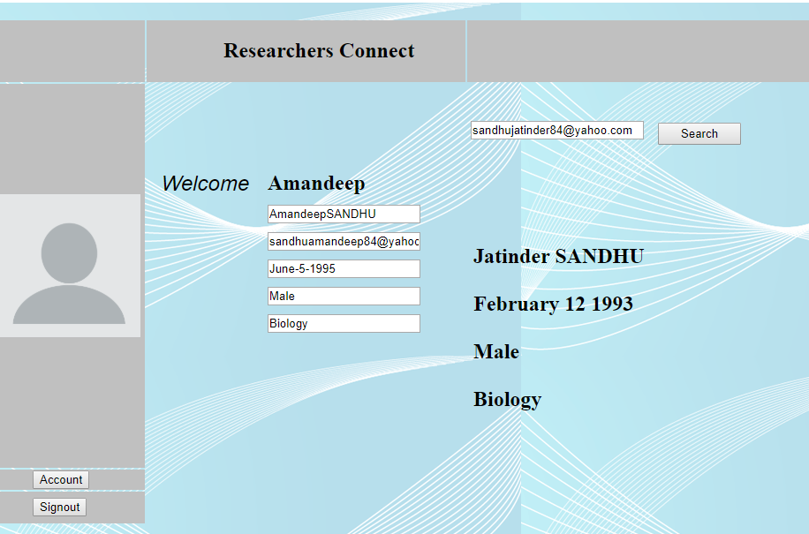

Description of source code of Login page:

using System;
using System.Collections.Generic;
using System.Linq;
using System.Web;
using System.Web.UI;
using System.Web.UI.WebControls;
using System.Data.SqlClient;
using System.Data;
using System.Configuration;

namespace Final_Project
{
public partial class Login : System.Web.UI.Page
{
SqlCommand cmd = new SqlCommand();
SqlConnection con = new SqlConnection();
SqlDataAdapter sda = new SqlDataAdapter();
DataSet ds = new DataSet();
protected void Page_Load(object sender, EventArgs e)
{
if(Session["User"]!=null)
{
Response.Redirect("Profile.aspx");

}
else
con.ConnectionString = "Data Source=(localdb)\\MSSQLLocalDB;Initial Catalog=Database1;Integrated Security=True"; }

protected void Button1_Click(object sender, EventArgs e)
{
con.Open();
string user = TextBox1.Text.Trim();
cmd.CommandText = "select * from singh where email='" + TextBox1.Text + "'and password='" + TextBox2.Text + "'";
cmd.Connection = con;
sda.SelectCommand = cmd;
sda.Fill(ds, "singh");
if(TextBox1.Text=="" && TextBox2.Text=="")
{
//Response.Write("Please fill all the fields");
Label1.Visible = true;
}
else if (ds.Tables[0].Rows.Count>0)
{
Session["user"] = user;
Response.Redirect("Profile.aspx");

}
else
{

ScriptManager.RegisterStartupScript(this, this.GetType(), "Message", "alert('Either username or Password is Incorrect');", true);
}

}
}

WEEK11:

Task:
Our role was again change to software tester and we have done the test cases for Login and Profile page.We had created the Microsoft Excel sheet with some additional phases by continuing the previous one as it helped us how to deal with different software to achieve a result for single web application.

Following report contains various Test cases which explains how application works in different kinds of processes.The basic requirement of each application is to make it error free so we can deal with our project without any bug.

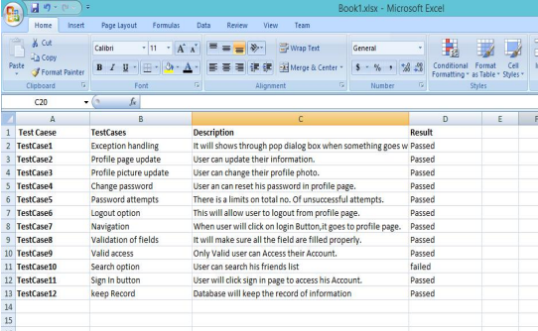

WEEK12:

Task:
During this week our role was as a ‘Junior System Analyst’ and all the members worked on the given mobile application.As we went on the website first to perform the given tasks.
- We created an account on slack added our team members started communication about on ResearchersConnect app and solve the errors related to our source code.There are some channels on which we have worked on such as @Researchers_Connect_coding
,@Researchers_Connect_dbteam
2.We also created an account on trello after this we created a board and added separate tasks in the board .Some of the tasks are created a SRS document,main page,profile page and database.
We went on the following links
- Slack (https://slack.com/)
- Trello (https://trello.com/)

Screenshot of Trello:

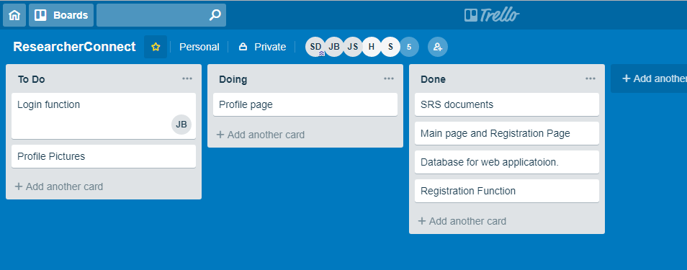

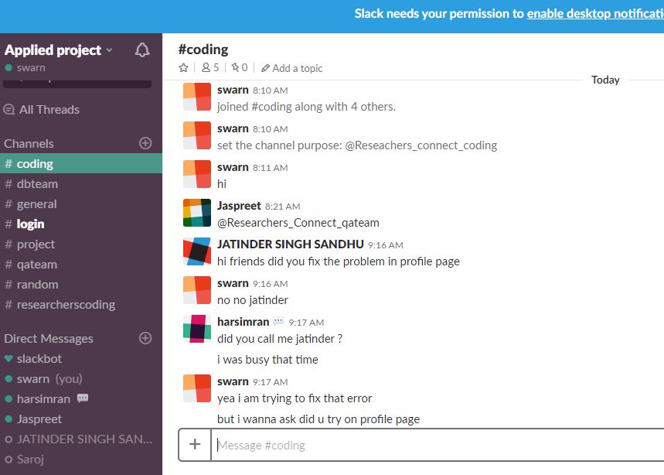

WEEK13:

Task:
In this week all have worked as a ‘Software Programmer’ to develop the source code in appropriate way.First made an account on GitHub and then we have done the process of sign up.After that we went on training session,red all the instructions and started our project.We created a name of repository and made it public and uploaded our project on it.

Check the following links:
http://github.com/

Here is the link of a website from where we can get the free training session:
http://help.github.com/articles/git-and-github-learning-resources/

Screenshot of GitHub:
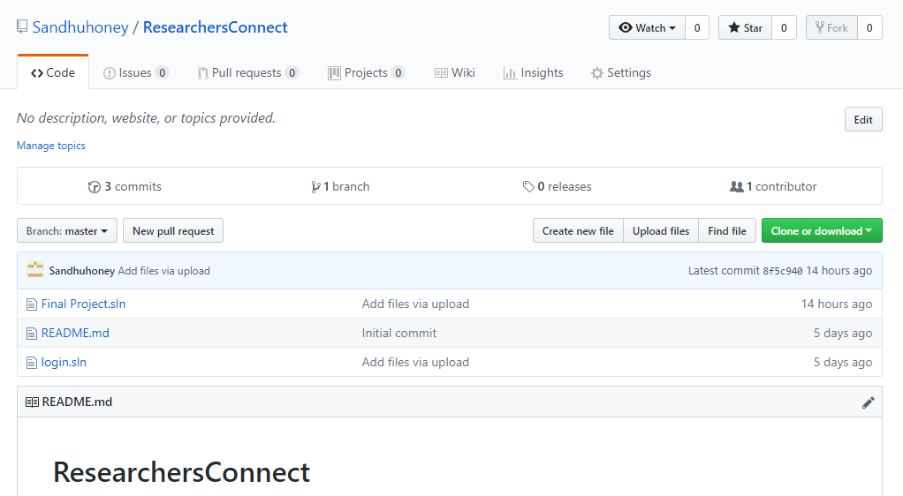

THANKS

